Chapter No 4
COMPONENTS OF COMPUTER
SYSTEM UNIT
REVISION:
Components of computer: Input, Output, CPU
System Unit: System unit is a case that contains all components which are very important for the processing of data.
Component of System Unit: Mother Board, CPU, Primary Memory, Ports & connectors, Expansion slots & Adaptor Cards, Buses, Power supply

WHAT IS DATA?
“Raw facts, figures, events and transactions are called data”
DATA REPRESENTATION
Most computers are digital, meaning they understand only two discrete states: on and off. These states are represented using two digits, 0 (off) and 1 (on). Each on or off value is called a bit (short for binary digit), the smallest unit of data a computer can handle. “Eight bits” grouped together as a unit form a byte. A byte provides enough different combinations of 0s and 1s to represent 256 individual characters including numbers, letters of the alphabet, punctuation marks, and other characters.

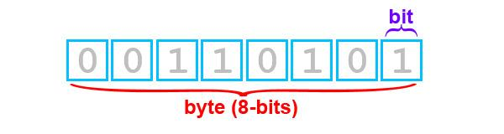

The combinations of 0s and 1s used to represent data are defined by patterns called coding schemes.
Popular coding schemes are ASCII (American Standard Code for Information Interchange) , EBCDIC, and Unicode. Coding schemes make it possible for humans to interact with a digital computer that recognizes only bits. Every character you type on a keyboard is converted into a corresponding byte, a series of on/off electrical states the computer can process.
The common data representation is formed in to following divisions:

NAME | ABBR. | SIZE
1 Nibble | N | 4-bits
1 byte | B | 8-bits
1 kilo byte | K | 2^10=1024 bytes
1 Mega byte | M | 2^20=1,048,576
1 Giga Byte | G | 2^30=1,073,741,824
1 Tera Byte | T | 2^40=1,099,511,627,776

WHAT IS BINARY?

The binary numbering system is used by today's computers due to its simplicity in electronic circuitry. Computer only work with two digits - 1 representing "on", and 0 representing "off" (or 1 and 0 representing "yes" or "no").

HOW TO MAKE BINARY
We can convert decimal function in to binary by following technique:
Example: if we want to convert 156 in to binary then we will divide it by 2.
2)156 0
2)78 0
2)39 1
2)19 1
2)9 1
2)4 0
2)2 0
2)1 1
0
HOW IS A LETTER REPRESENTED IN SYSTEM PROCESSING?
Data is represented in system by a life cycle defined below:


Press P from keyboard
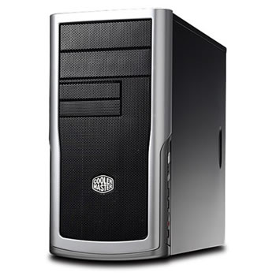

Processing
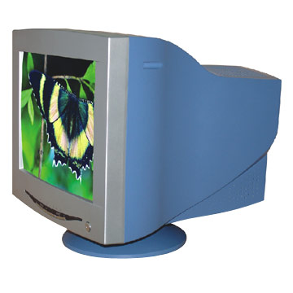
Display

WHAT IS STORAGE?
A Storage Medium (media is the plural) is the physical material on which items are kept. A storage device is the computer hardware that records and retrieves items to and from a storage medium. Storage devices can function as sources of input and output.
When storage devices transfer items from a storage medium into memory – a process called reading – they function as sources of input. When storage devices transfer items from memory to a storage medium – a process called writing – they function as sources of output. Types of storage media include floppy disks, hard disks, compact discs, tape, PC Cards and microfilm etc.
DIFFERENCE B/W MEMORY & STORAGE MEDIUM
Memory, which is composed of one or more chips on the motherboard, is a temporary holding place for data and instructions during processing. The contents of volatile memory, such as RAM, are lost when the power to the computer is turned off.
The contents of nonvolatile memory, such as ROM, are not lost when power is removed from the computer.
Storage holds items such as data, instructions, and information for future use; that is, storage holds these items while they are not being processed. Storage is nonvolatile, which means the items in storage are retained even when power is removed from the computer. Compared to memory, the access time (the time it takes to locate a single item) for storage is slow.
TYPES OF STORAGE MEDIUM
Storage medium is further divided in to three important forms.
- Magnetic Tapes
- Magnetic Disks
- Optical Disks
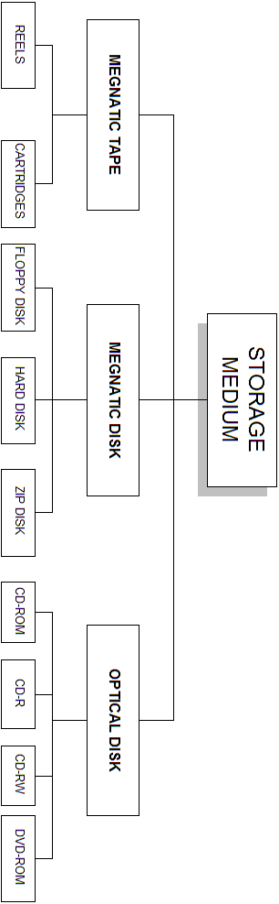

1) MAGNETIC TAPE
Magnetic tape was developed in the mid-1950s to replace the earlier method of storing data on punched cards. To better understand the difference between sequential access and direct access (or random access), compare an audio cassette tape to a CD-ROM. An audio cassette tape is sequential; to listen to the fourth song it is necessary to listen to (or fast-forward through) the first three songs.
With tape backup, you can press a key; go about other business, and return to remove the finished backup tape.
TYPES OF MAGNETIC TAPE:
Magnetic tape comes in two different forms:
- Reels
- Cartridges
REELS:
Large reels of tape (1/2 inch wide and 2400 feet long) which must be loaded into a reel-to-reel tape drive. This type of tape is usually used by mainframe computers.

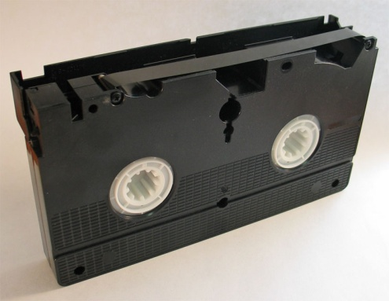
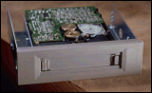

CARTRIDGES:
The tape is supplied in a small cartridge rather like a music tape. The tape is typically 1/4 inch wide and 300 feet long. This type of tape is used on PCs (microcomputers) and the device used to read/write the tapes is called a Tape Streamer.
The picture below is of a tape streamer for a PC. Capacities of cartridges vary from 80Mb to 10Gb. Tape cartridges can be purchased formatted or unformatted. One-quarter-inch wide cartridge tapes typically are 600 feet long. Unattended tape backup is a great time saver.
2) MAGNETIC DISKS
Magnetic Disks are the most common storage device. Data is stored using magnetized spots called domains on the disk. A 3.5" 1.44Mb floppy disk used on a PC contains 16,777,216 such spots. A 3.5" 1Gb hard disk drive contains over a billion spots.
Data stored on disks is arranged along a series of concentric rings called Tracks. Each track is divided up into a number of Sectors. Data is read to and written from a disk one sector at a time. A sector usually contains 512 or 1024 bytes of data.
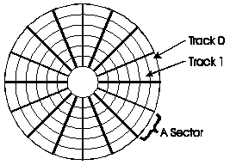

The process of dividing a disk up into tracks and sectors so it can be used on a computer is known as formatting. You must format a new disk before you can use it.
Data is read from the disk using a disk head which moves mechanically about the disk (rather like a record player tone arm). The disk head can move directly to any sector on the disk. Because of this a computer system can load a file or a record from a file very quickly. The system can move directly to the location of the record/file and read it without having to read any other data from the disk. This is known as direct access. For most applications using a direct access medium is much faster than using a serial access medium.
TYPES OF MEGNATIC DISK
The three main types are:
- Floppy disks
- Magnetic disks
- Hard disks
FLOPPY DISK
Floppy disks are portable (can be moved between computers) but have a small storage capacity. Reading and writing data from a floppy disk is very slow. The most common type of floppy disk is the 3.5" disk that can store 1.44Mb of data when it is used on a PC. Older disks were 5.25" or 8" in size but could store much less data.
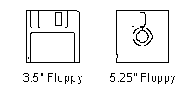
A floppy disk is manufactured from a flexible plastic disk. This disk is coated with a magnetisable material. For protection the disk is encased in a plastic shell. All sizes of floppy disk have a write protect tab built into the shell. If this tab is set then data can be read from the disk but not written to it. The write protect tab can be used to prevent important data being deleted or changed accidentally.
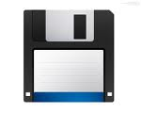

HARD DISK
Hard disks have much larger storage capacities than floppy disks. Data can be transferred to and from a hard disk much more quickly than from a floppy disk. Hard disks are usually fixed inside a computer and cannot be moved between different machines. Some expensive hard disks can be moved between computers. These are called Exchangeable Hard Drives.
A hard disk is made of a rigid disk which is coated with a magnetisable material. The magnetic material used is of a much higher quality than that found on floppy disks. Hard disks spin much more quickly than floppy disks and the disk head is positioned very close to the disk (thousandths of a millimeter away).
Because the disk head is positioned so close to the disk hard drives can easily be damaged by dust or vibration. Therefore the disk, the drive head and all the electronics needed to operate the drive are built together into a sealed unit.
This picture shows a hard disk drive with the case removed.
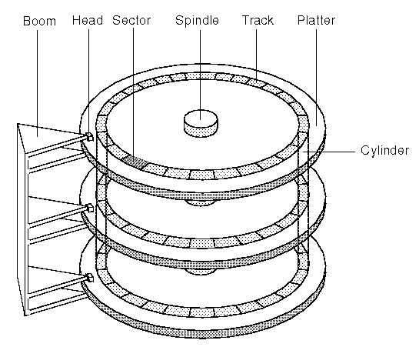
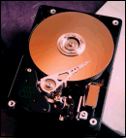

Usually (as in the picture above) several physical disks are contained in one hard disk unit. Each disk is known as a platter. Typical hard disk capacities for a home PC now start at 1Gb and units storing up to 16Gb are available.
If larger storage capacities are required then multiple hard drives can be combined. Using appropriate hardware or software many hard disks can be made to look like one very large hard disc to the user.
ZIP DISK
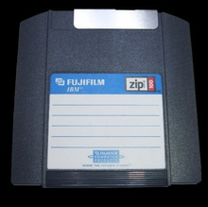
The Zip drive is a high-capacity disk drive that uses a Zip disk. The Zip disk is larger and thicker than a 3.5-inch floppy disk and can store 100 MB or 250 MB of data. The Zip drive is a medium-capacity removable disk storage system, introduced in late 1994. Originally, Zip disks launched with capacities of 100 MB, but later versions increased this to first 250 MB and then 750 MB.

The format became the most popular of the super-floppy type products which filled a niche in the late 1990s portable storage market. However it was never popular enough to replace the 3.5-inch floppy disk nor could ever match the storage size available on rewritable CDs and later rewritable DVDs. USB flash drives
3) OPTICAL DISK
Optical disks store data by changing the reflective properties of a plastic disk. Binary computer data (0s and 1s) are represented by the way the disk reflects light when a low power laser is shown at it. A 0 stored on a disk reflects light differently to a 1 stored on a disk. Like floppy disks, optical disks can be moved from one computer to another.
They have much larger storage capacities than floppy disks but cannot store as much data as a hard disk. Data can be read from an optical disk more quickly than from a floppy disk but hard disks are much quicker. As with a hard disk the drive head in an optical drive can move directly to any file on the disk so optical disks are direct access.

There are four types of optical disks that are currently in use. They are:
- CD-ROM
- CD-R
- CD-RW
- DVD

CD-ROM
CD ROM stands for Compact Disk - Read Only Memory This is by far the most widely used type of optical disk. A CD-ROM disk can store up to 650Mb of data. The data is written onto the CD-ROM disk before it is sold and cannot be changed by the user. Because of this CD-ROMs are often described as Write Once Read Many times (WORM) disks. CD-ROMs are used for applications such as distributing software, digital videos or multimedia products.
CD-R
CD-R stands Compact Disc – Recordable. CD-R disk can store up to 650Mb of data. A CD-R disk is blank when it is supplied. The user can write data to it just once. After data has been written to the disk it can not be changed. A special CD-R drive which contains a higher powered laser than a CD-ROM drive is required to write to the disk. CD-Rs are often used for making permanent backups of data and distributing software when only a small number of copies are required.
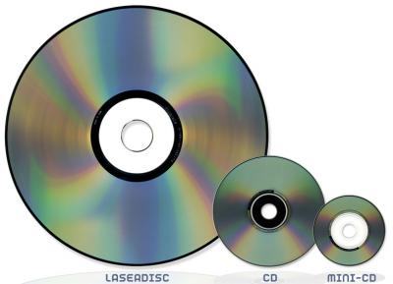

CD-RW
A CD-RW stands for Compact Disc - Read / Write. The disk can store up to 650Mb of data. CD-RW disks can be read from and written to just like a hard disk. CD-RWs can be used for any application that a hard disk can be used for but the time taken to access data is much longer than that for a hard disk.

DVD
DVD stands for Digital Versatile Disk or Digital Video Disk. This new standard for optical disks. By using a shorter wavelength laser, storing data on both sides of the disk and having more than one layer of data on each side of a disk DVD disks are able to store much more data than CD disks.
The DVD standard includes disk capacities up to 18Gb. Current DVD disks store far less than this. There are two types of DVD disks. DVD-ROM disks can be read from but not written to whilst DVD-RAM disks can be read from and written.

STORAGE CAPACITIES
NAME | STORAGE CAPACITY | PORTABLE
Floppy Disk | 1.44Mb | Yes
Hard Disk | 200Mb to 20Gb | No
Optical Disk | 650Mb | Yes
Magnetic Tape | 80Mb to 10Gb | Yes

USB FLASH DRIVE
A flash drive is a small external storage device that reads and writes to flash memory, a solid-state storage medium that's both inexpensive and durable. Given that your typical flash drive is the size of an adult's thumb, it's not uncommon to hear of these ubiquitous devices as "thumb drives". Due to their portable nature and near-universal compatibility, flash drives have largely supplanted the floppy diskette as everyone's favorite method for transferring files between multiple computers without the use of a network.

